Bangladesh Hi-Tech Park Authority (BHTPA)
Brief on Each Park (As on February 2022)

Sl. | Items | Remarks/Options | To be filled with
1 | Park Title: | (Full Name and Short name if any)
2 | Park Introduction: | (Brief Description)
3 | Area of Land: | (In Acres)
4 | Park Location: | - Mouza  - Union  - Upazila  - District
5 | Communication: | - By Road  - By Train  - By Air
6 | Distance: | - From City Center  - From Air Port  - From Railway Station
7 | Existing Infrastructure: | (Brief Description)
8 | Employment Target: | (Nos)
9 | Park Developer: | - BHTPA  - Private Developer
10 | Park Owner: | - Government Owned/BHTPA  - Privately Owned
11 | Park Management: | - BHTPA  - Property Management Company
12 | Readiness: | - Ready for Investment  - Under Construction
13 | Availability of Land/Space: | - Ready Land Available  - Ready Space available  - Ready Land Not Available  - Ready Space Not available
14 | No. of Investors at present | (Nos)
15 | Rate of Rent: | - For Land  - For Space
16 | Remarkable Photos: | Softcopy for Display

[Sample Information Need to be upgraded]

Hi-Tech Park - Prospective Gateway of Investment & Employment

Bangladesh Hi-Tech Park Authority (BHTPA) is establishing Hi-Tech Park, Software Technology Park and IT Training & Incubation Centre throughout the country to attract the local and foreign investors for the development of Hi-Tech/ IT/ITES industries. It creates huge employment opportunities and skilled human resources. Hi-Tech park is full of opportunities to invest in Hi-Tech industry and promote business which are knowledge and capital-based. Information technology, Software Technology, Bio-Technology, Renewable Energy, Green Technology, IT Hardware, IT Enabled Services and R&D etc. are major areas of investment in Hi-Tech industry in Bangladesh. At present 28 Park sites are under development by BHTPA.

Brief on Hi-Tech Parks:
Sl. | Park Name and Brief Description |  | Photo
1. | Bangabandhu Hi-Tech City, Kaliakoir |  | 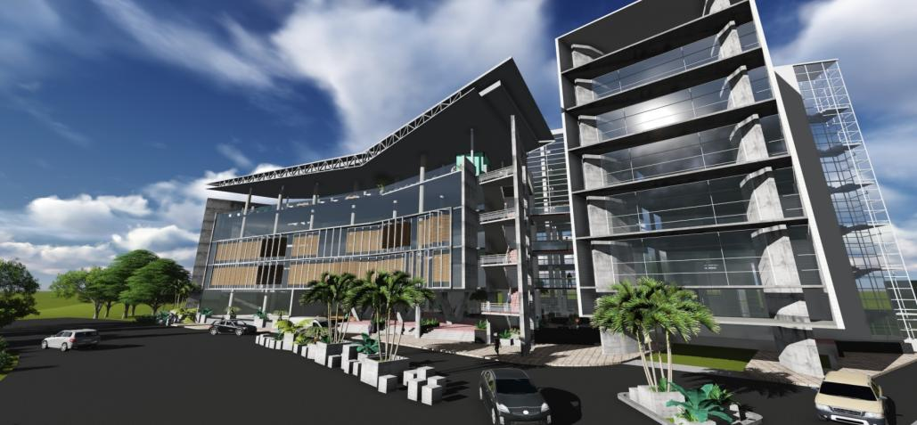
 | Area of Land: | 355 Acre
 | Location: | KaliakoirUpazila, Gazipur
 |  | 40 km North from Dhaka
 |  | 25 km fromShajalal International Airport
 | Travel Time from Dhaka: | By Road- 1.30 hour;  By Rail- 1 hour;  By Helicopter- 15 min
 | Existing Infrastructure: | Factory Building (58,960 sft), Signature Building (1,53,185 sft), Solaris Building (2,00,000 sft), Industrial Building (25,000 sft),Admin Building (3 storied), Service Building (2 storied),and Four Tier Data Centre.
 | Employment Target: | 1,00,000 | 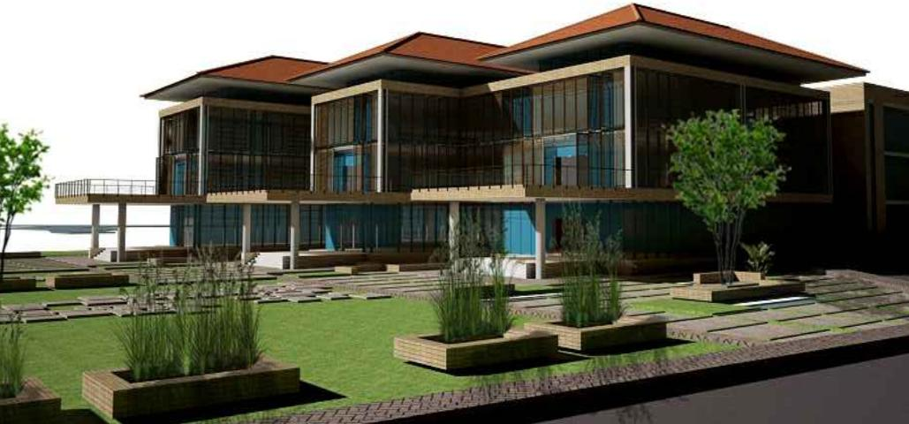
 | Park Developer: | - Bangladesh Hi-Tech Park Authority
 |  | - Park Developer and Investors
 | No. of Investors at Present: | 25
 | Rate of Rent: | Ready Space- per sft BDT 30-50 per month;  Land- per sqm USD 4-6 per year
 | Ready Land/Space availability: | Ready Land/Space

Sl. | Park Name and Brief Description |  | Photo
2. | Sheikh Hasina Software Technology Park, Jashore |  | 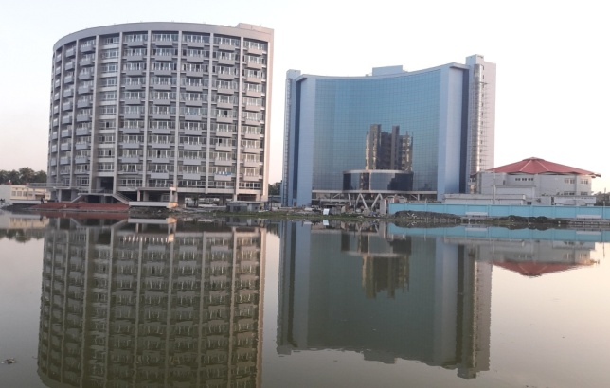
 | Area of Land: | 12.13 Acre
 | Location: | SadorUpazila, Jashore
 |  | 2.4 km East from Jashore
 |  | 8 km from Jashore Airport
 | Travel Time from Dhaka: | By Road- 6 hour;  By Rail- 8 hour;  By Air- 30 min
 | Existing Infrastructure: | 15 Storied MTB (2,32,000 sft); 12 StoriedDormitory (98,000 sft); Canteen & Amphitheatre (3 Storied)
 | Employment Target: | 5000
 | Park Developer: | Bangladesh Hi-Tech Park Authority
 | Park Management: | Property Management Company
 | No. of Investors at Present: | 48
 | Rate of Rent: | Ready Space- per sft BDT 10 per month;  Service Chargepersft BDT 2 per month;  (Rent increasable in every 2 years)
 | Ready Land/Space availability: | Ready Land Available  Ready Space Available

Sl. | Park Name and Brief Description |  | Photo
3. | Software Technology Park, Janata Tower-2021 |  | 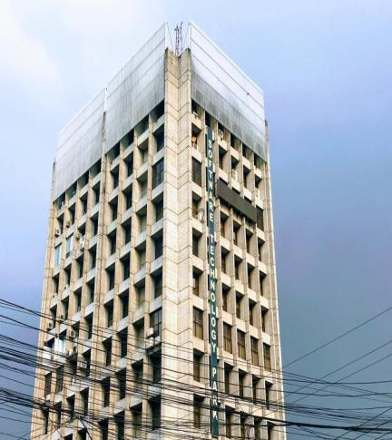
 | Location: | Karwan Bazar, Dhaka
 |  | 5.4 km North from Zero Point, Dhaka
 |  | 25 km from Shajalal International Airport
 | Existing Infrastructure: | 12 Storied Building (72,000 sft)
 | Present Employment: | 870
 | Park Development & Management: | Bangladesh Hi-Tech Park Authority
 | No. of Investors at Present: | 18 Company + 13 Start Up Company
 | Rate of Rent: | Ready Space- per sft BDT 30 per month;  Service Chargepersft BDT 5 per month;  (Rentincreasable in every 3 years)
 | Ready Land/Space availability: | Ready Land Not Available  Ready Space Available

Sl. | Park Name and Brief Description |  | Photo
4. | Bangabandhu Sheikh Mujib Hi-Tech Park, Rajshahi (under construction) |  | 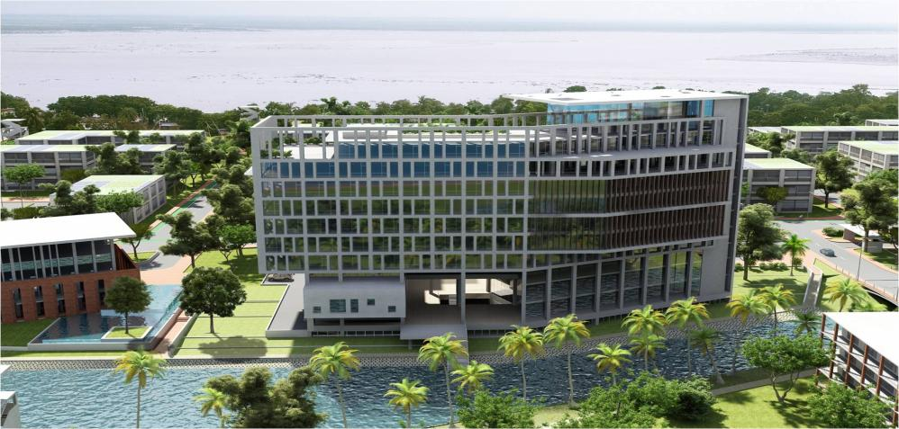
 | Area of Land: | 30.67 Acre
 | Location: | Rajshahi City Corporation
 |  | 3 km West from zero point
 |  | 8 km from Hazrat Shah Makhdum Airport
 | Travel Time from Dhaka: | By Road- 6 hour;  By Rail- 6 hour;  By Air- 30 min
 | Infrastructure (Under Construction): | MTB (10 Storied, 2,70,000 sft); Dormitory (8 Storied, 87,265 sft),
 | Employment Target: | 14,000
 | Park Development & Management: | Bangladesh Hi-Tech Park Authority
 | Training Target (Under the Project): | 3337
 | Ready Land/Space availability: | Ready Land Available  Ready Space Available

Sl. | Park Name and Brief Description |  | Photo
5. | Hi-Tech Park, Sylhet (Sylhet Electronics City)  (Under Construction) |  | 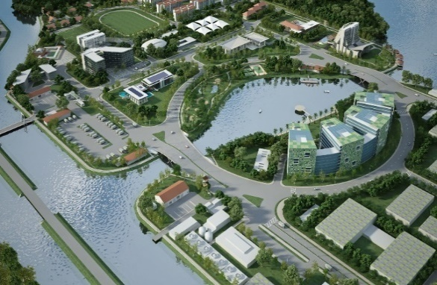
 | Area of Land: | 162.83 Acre
 | Location: | Companiganj, Sylhet
 |  | 22 km North from the Sylhet City
 |  | 18 km from Osmani International Airport
 | Travel Time from Dhaka: | By Road- 6 hour;  By Rail- 6 hour;  By Air- 30 min
 | Infrastructure (Under Construction): | Admin Building (3 storied, 31,077 sft)
 | Employment Target: | 50,000
 | Park Development & Management: | Bangladesh Hi-Tech Park Authority
 | Rate of Rent: | Land- per sqm USD 1.5 per year
 | Ready Land/Space availability: | Ready Land Available  Ready Space Available

Sl | Park Name and Brief Description |  | Photo
6. | Sheikh Kamal IT Training and Incubation Centre, Natore |  | 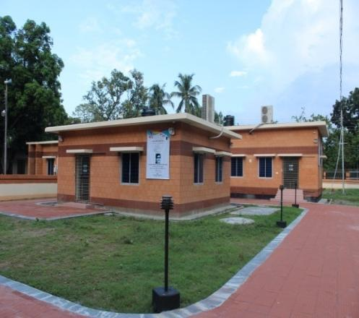
 | Area of Land: | 1.239 Acre
 | Location: | NatoreSador
 |  | 0.5 km from Natore
 | Travel Time from Dhaka: | By Road- 5 hour;  By Rail- 5 hour;
 | Existing Infrastructure: | Incubator Building (2 Storied, 10,000 sft);  2 Training Building (1400sft)
 | Present Employment: | 799
 | Park Development & Management: | Bangladesh Hi-Tech Park Authority
 | Training (Under the Program): | 480 persons have been trained
 | Ready Land/Space availability: | Ready Land Not Available  Ready Space Available

Sl. | Park Name and Brief Description |  | Photo
7. | Sheikh Kamal IT Training and Incubation Centre (Under Construction) |  | 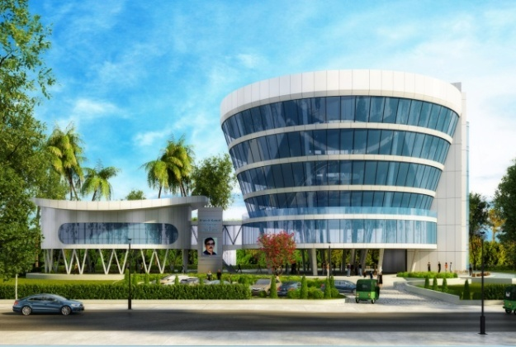
 | Sylhet (Companiganj) | Each Centre (6 Storied, 35,540sft)  Training Target (Under the Project): 15000 (for the students of SSC & HSC or equivalent);  3100 persons are being trained
 | Natore (Singra)
 | Netrokona (Sador)
 | Barishal (Sador)
 | Magura (Sador)
 | Cumilla(Lalmai)
 | Chattogram (City Corporation)

Sl. | Park Name and Brief Description |  | Photo
8. | IT/Hi-Tech Park at District Level (12 district)(Under Construction) |  | 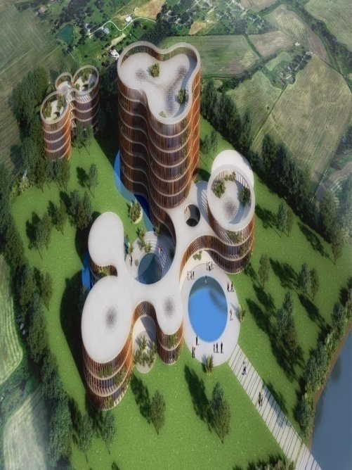
 | Rangpur (Sador) | Each Park MTB Building (7 Storied, 1,05,000 sft);  Canteen & Amphitheatre (3 Storied, 21,000 sft)  Employment Target:60000;  Training Target (Under the Project): 30000 and 100 Advanced Training (AI, IOT, Machine Learning, Cyber security, Data Science)
 | Natore (Singra)
 | Khulna
 | Barishal (Sador)
 | Dhaka (Keraniganj)
 | Gopalganj (BSMRSTU)
 | Mymensingh(Sador)
 | Jamalpur (Sador)
 | Cumilla(Sador South)
 | Chattogram (Sador)
 | Cox’sbazar (Ramu)
 | Sylhet (Companiganj)

Sl. | Park Name and Brief Description |  | Photo
9. | IT Business and Incubation Centre, CUET  (Under Construction) |  | 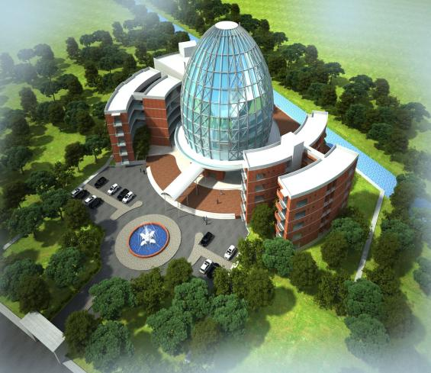
 | Area of Land: | 4.7 Acre
 | Location: | Chattogram University of Engineering and Technology (CUET)
 |  | 27.1 km from Chattogram Railway Station
 |  | 29.8 km from Chattogram Port
 |  | 42.9 km from Hazrat Shah Amanat International Airport
 | Infrastructure (Under Construction): | Incubator Building 72000 sq ft
 | Employment Target: | This would be a Innovation and Commercialization Hub
 | Park Development: | Bangladesh Hi-Tech Park Authority
 | Management: | BHTPA and KUET
 | Training Target (Under the Project):

Sl. | Park Name and Brief Description |  | Photo
10. | IT Business and Incubation Centre,  Rajshahi (under construction) |  | 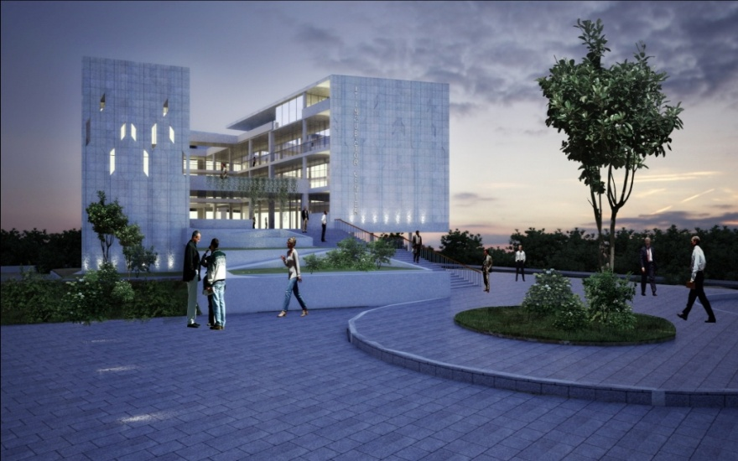
 | Area of Land: | 4 Acre
 | Location: | Rajshahi City Corporation
 |  | 3 km West from zero point
 |  | 8 km from Hazrat Shah Makhdum Airport
 | Travel Time from Dhaka: | By Road- 6 hour;  By Rail- 6 hour;  By Air- 30 min
 | Infrastructure (Under Construction): | Incubator Building (5 Storied, 72,000 sft),
 | Employment Target: | 300
 | Park Development & Management: | Bangladesh Hi-Tech Park Authority
 | Training Target (Under the Project): | A training Centre will be set there.

Sl. | Park Name and Brief Description |  | Photo
11. | ICT Incubator Cum Training Center, KUET (under construction) |  | 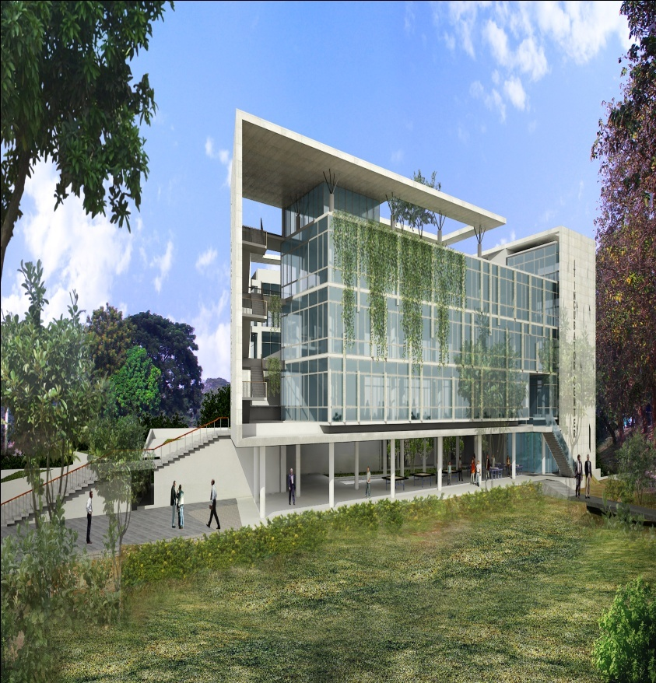
 | Area of Land: | 8 Acre
 | Location: | Khulna University of Engineering and Technology
 |  | 12 km from zero point of Khulna
 |  | 56 km from Jashore Airport
 | Travel Time from Dhaka: | By Road- 8 hour;  By Rail- 8 hour;
 | Infrastructure (Under Construction): | Incubator Building (5 Storied, 72,000 sft),
 | Employment Target: | 300
 | Park Development & Management: | Bangladesh Hi-Tech Park Authority
 | Training Target (Under the Project): | A training Centre will be set there.

