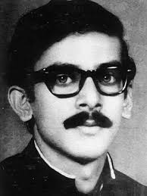

Photo

Sheikh Kamal IT Training & Incubation Center in Natore
Application form for Registration
Date: 25.09.2017 - 15.11.2017
Minimum Academic Qualification: H.S.C Complete
(Office Copy)

Registration No:

Name of Applicant: ........................................................................................................

Email: .................................................................................
.
Mobile Number (Personal): ............................................ Mobile Number (Guardian): .............................................

Present Address (Details): .................................................................................................................................
.................................................................................................................................

Permanent Address (Details): ..........................................................................................................................
...........................................................................................................................

Choose all courses gradually:
- Computer Hardware and Networking Trouble Shoot
- Graphic Design
- Web Design and Development

Training Time:
- 10.00am To 01.00pm
- 02.00pm To 05pm

Previous Related IT Training (if obtained)*
- Propose Course
- Others Course

Occupation:
- Student
- Service
- Startup
- Entrepreneur
- Business

Objective to attend the course:
........................................................................................................................................................................................

Sheikh Kamal IT Training & Incubation Center in Natore
Application form for Registration
(Student Copy)
Registration No:

Name of Applicant: ........................................................................................................

Email: .................................................................................
.
Mobile Number (Personal): ............................................ Mobile Number (Guardian): .............................................

