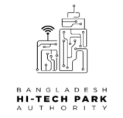
Bangladesh Hi-Tech Park Authority
Information and Communication Technology Division
Ministry of posts, Telecommunications & Information Technology
ICT Tower, Agargon, Dhaka-1207
Office copy
www.bhtpa.gov.bd
Sl | Description | Quality | purpose
The above …………..items allowed taking outside of the office.

Recipients name and signature officer in charge authorized officer

Bangladesh Hi-Tech Park Authority
Information and Communication Technology Division
Ministry of posts, Telecommunications & Information Technology
ICT Tower, Agargon, Dhaka-1207
Bearer copy
www.bhtpa.gov.bd
Sl | Description | Quality | purpose
The above …………..items allowed taking outside of the office.

Recipients name and signature officer in charge authorized officer

